Import Index Component Price Information (Updated)
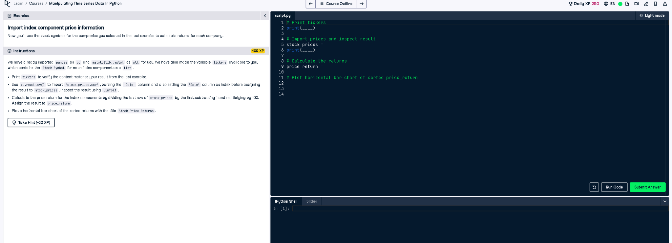

✅ Updated Full Correct Code:
# Print tickers
print(tickers)
# Import prices and inspect result
stock_prices = pd.read_csv("stock_prices.csv", index_col="Date", parse_dates=True)
print(stock_prices.info())
# Calculate the returns
price_return = (stock_prices.iloc[-1] / stock_prices.iloc[0] - 1) * 100
# Plot horizontal bar chart of sorted price_return
price_return.sort_values().plot(kind='barh', title="Stock Price Returns")
plt.show()

📘 Explanation (Simple Terms):
This code imports stock prices for selected companies, calculates percentage returns from the first to last date, and displays a horizontal bar chart. The plt.show() function is used to ensure the chart appears, especially important when running the code outside notebooks or interactive environments.

